**Plain text in crypto tool**

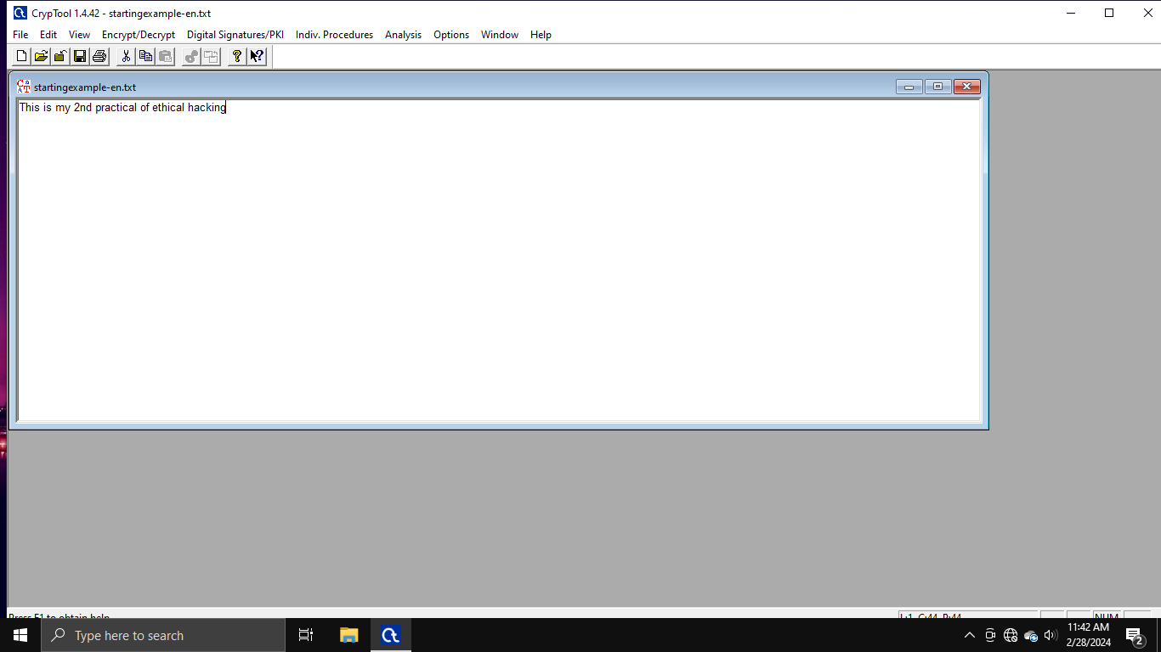

**Encryption of the plain text:**

**Select Encrypt/Decrypt from Menu bar**

**Then select Symmetric(Modern)**

**Then select RC4**

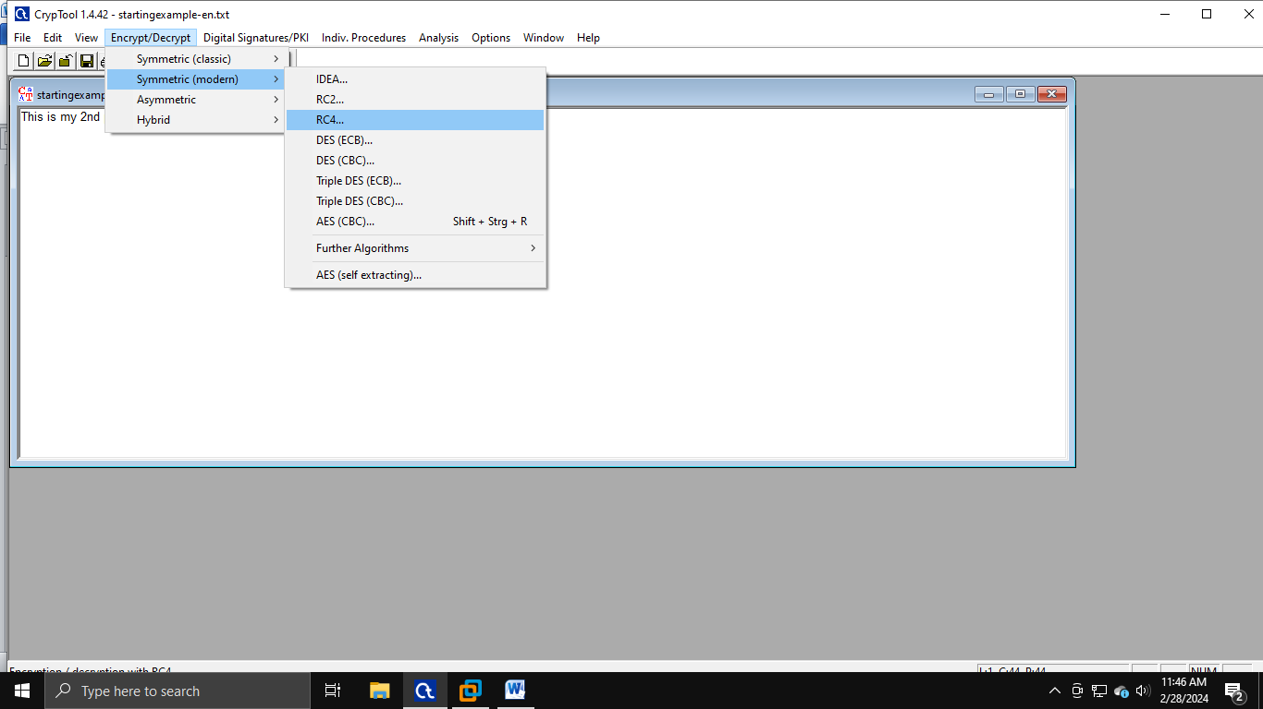

**Then select the key length: Example: 8 bits**

**Then select the secret key: For example I selected 06**

**Click on option Encrypt.**

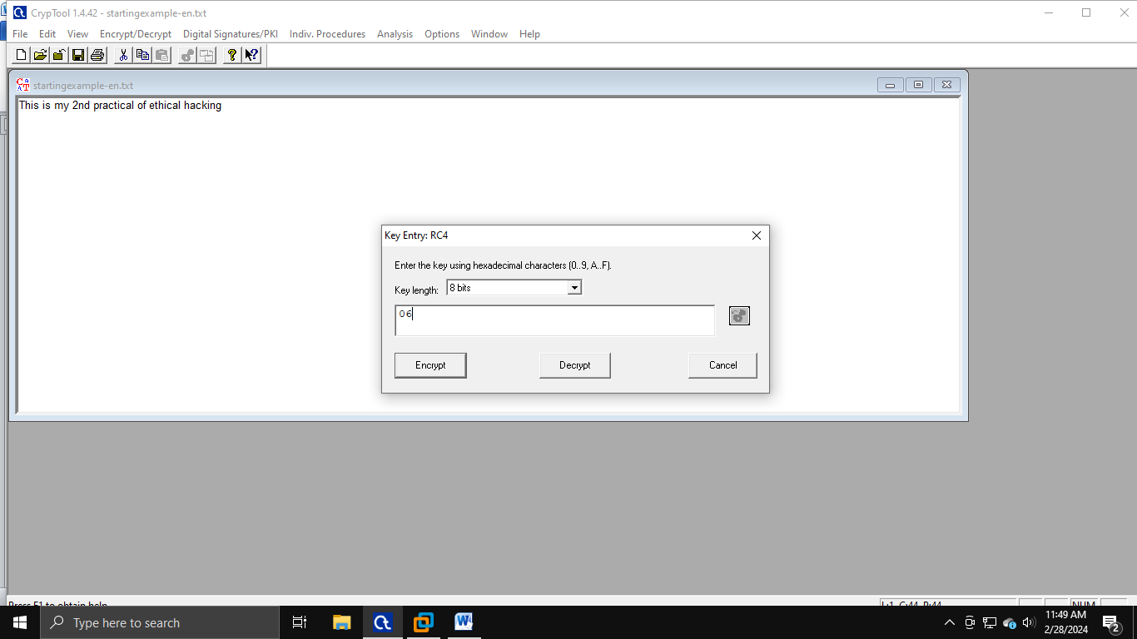

**We will get the encrypted text here**

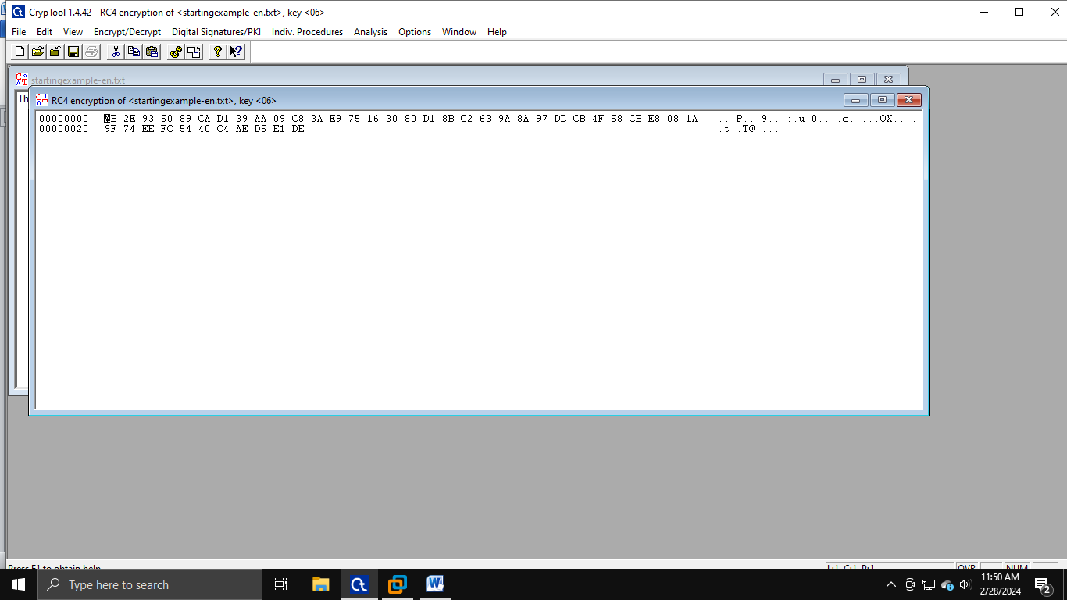

**Same Process for decryption as we done for the Encryption method:-**

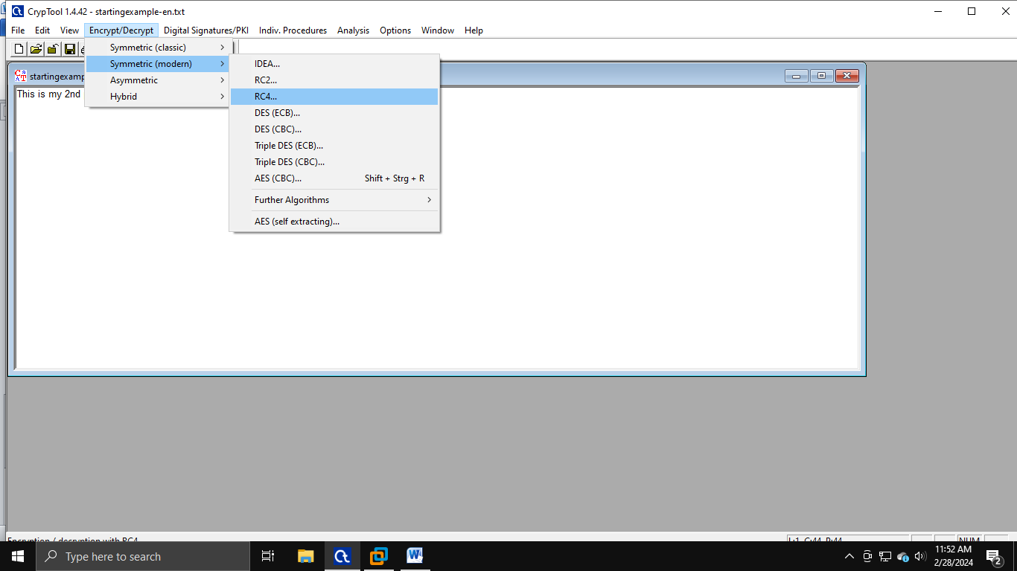

**Now select the length as above and also select the key as above click on Decrypt**

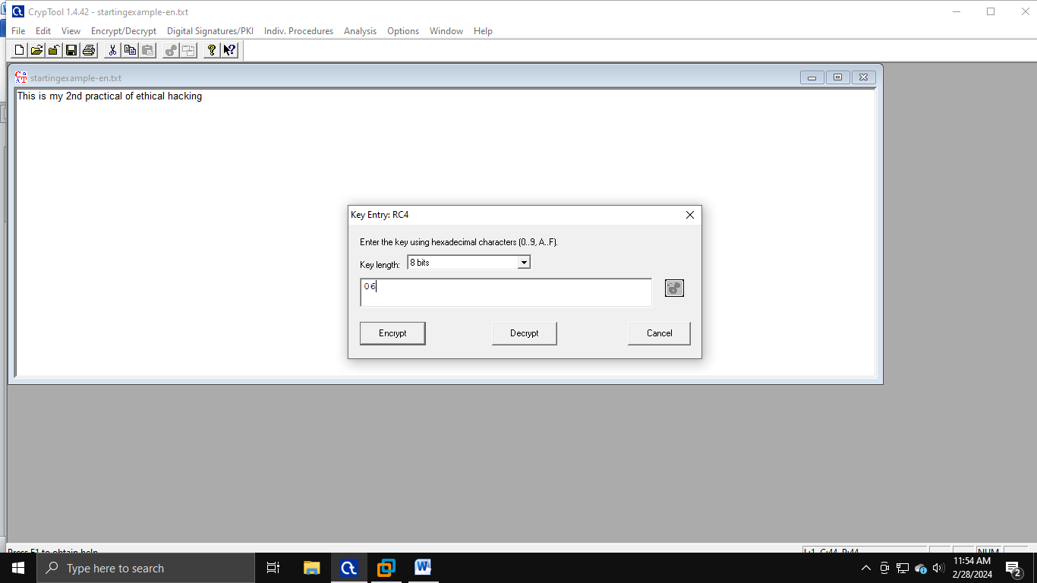

**We will be displayed with plain text**

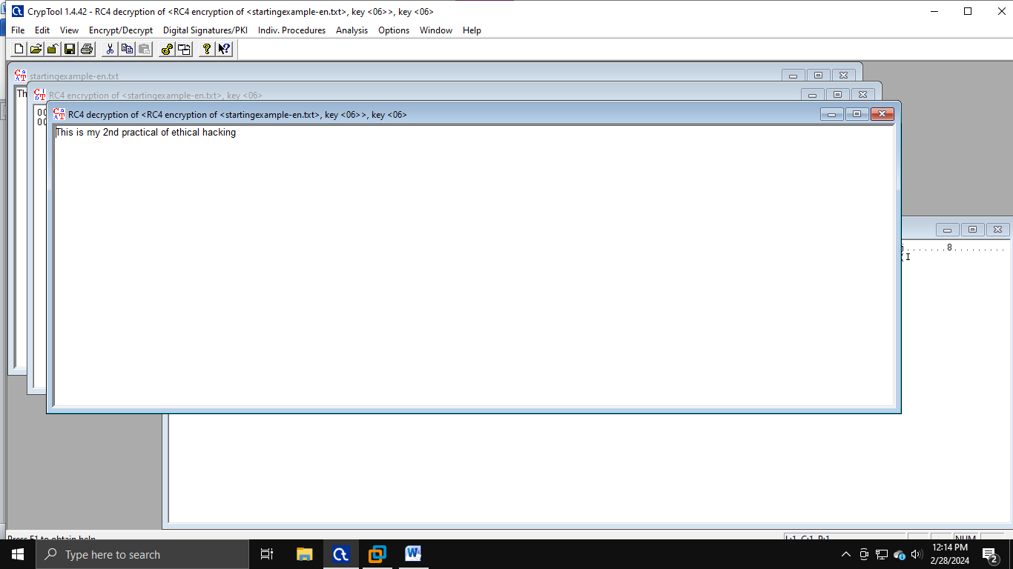

**Crypto tool using RC2:-**

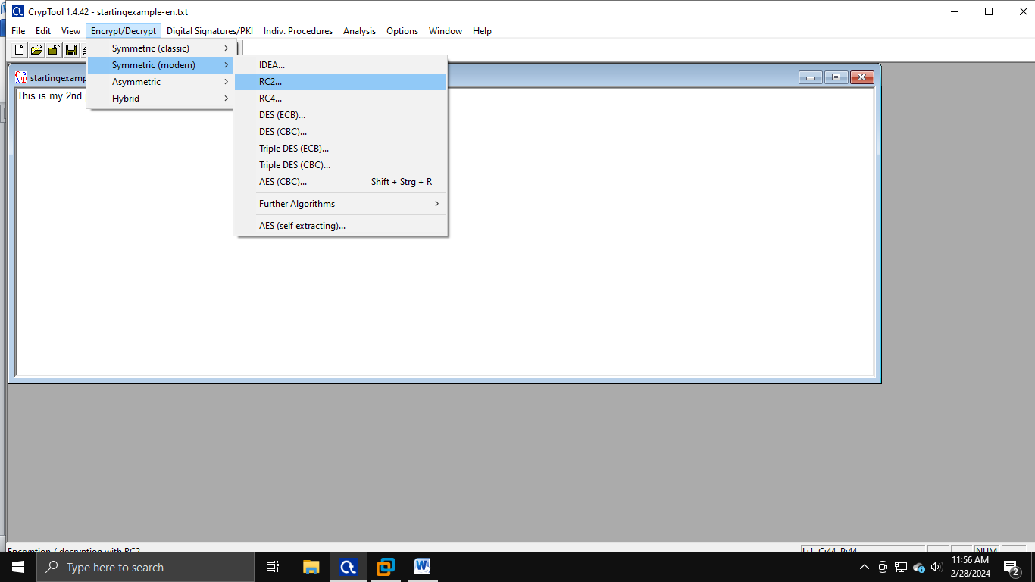

**Encrypt:**

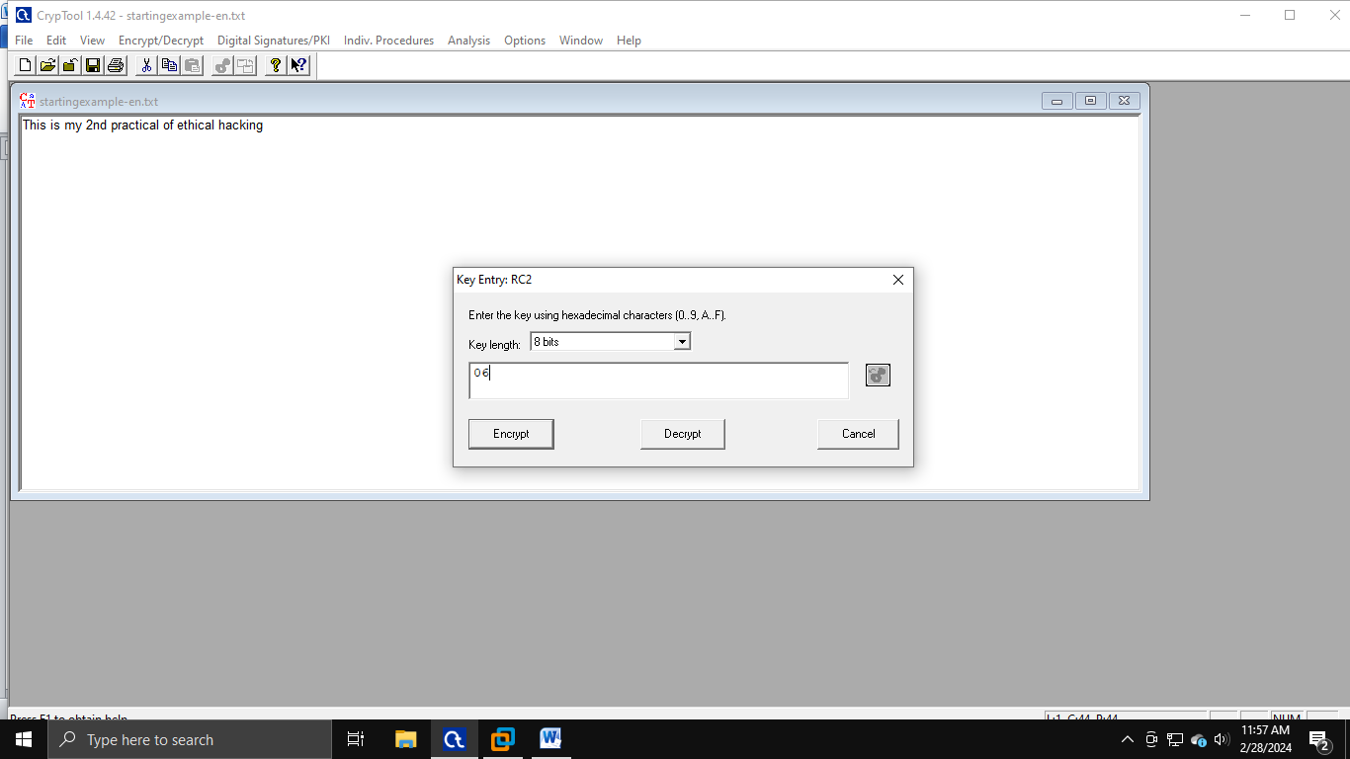

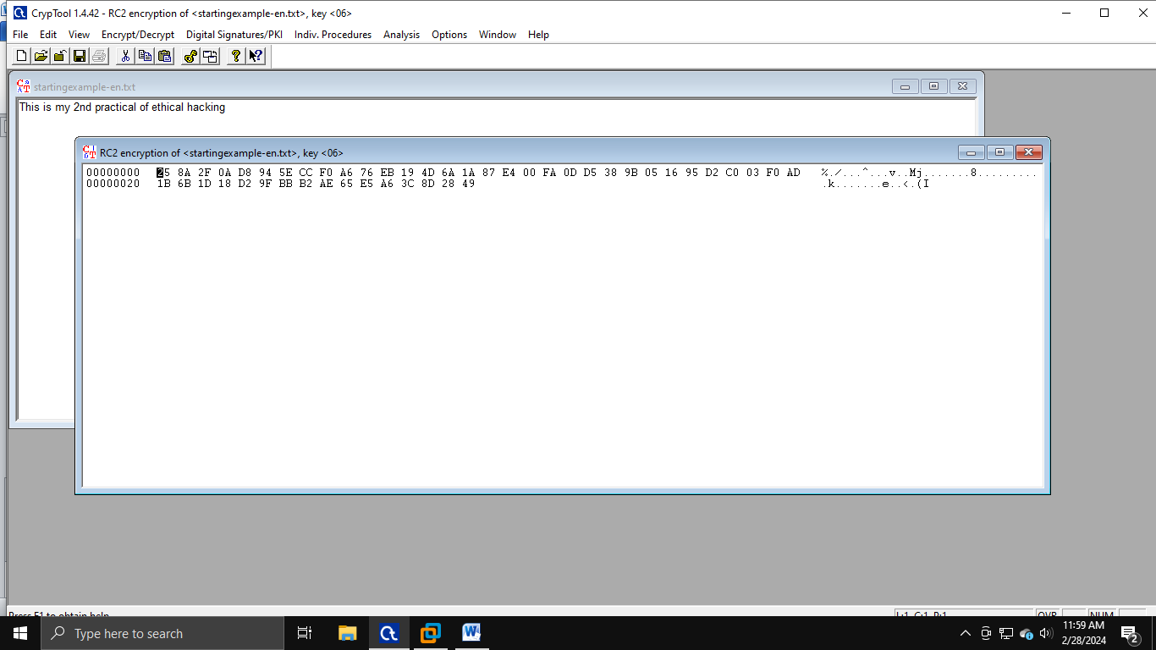

**Decrypt:**

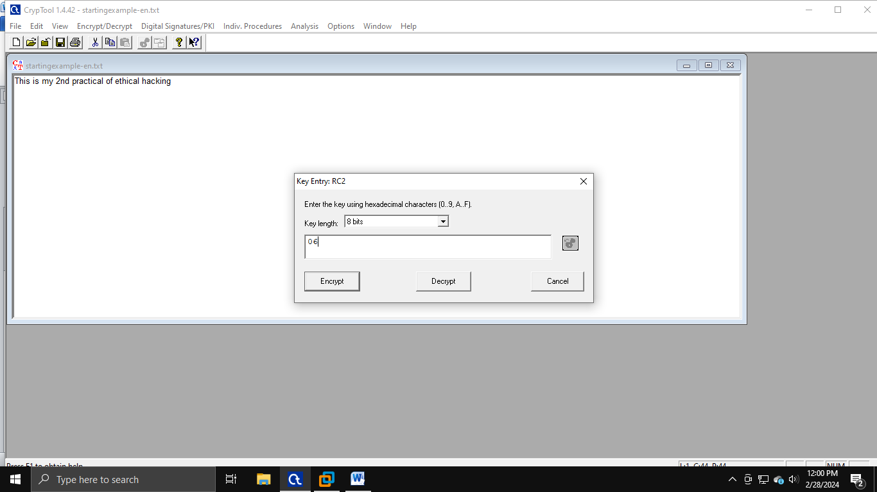

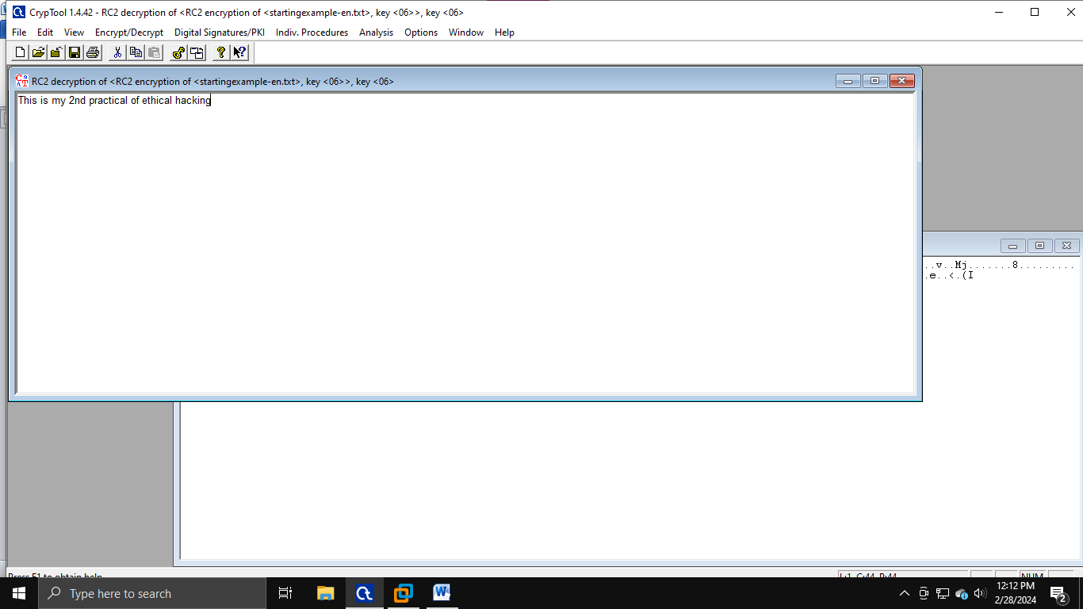

**Using DES (ECB):**

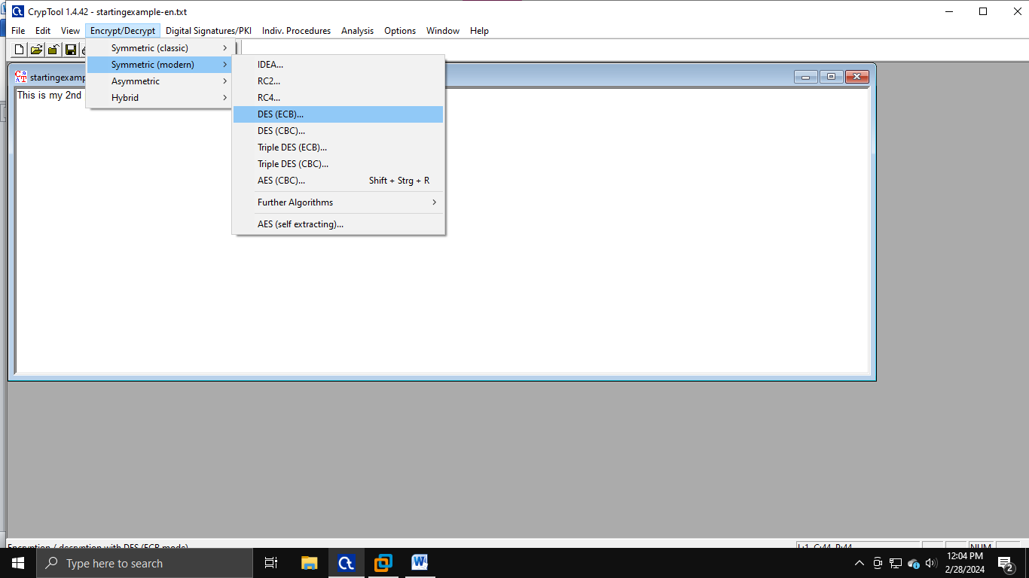

**Encrypt:**

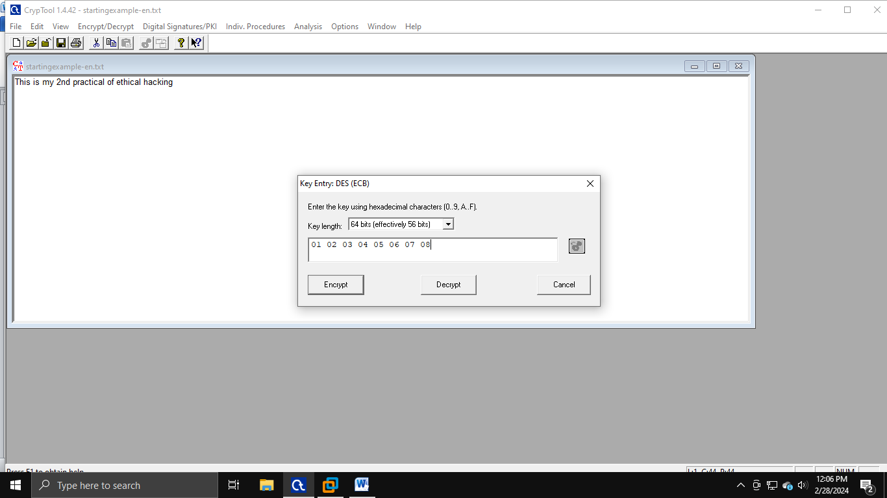

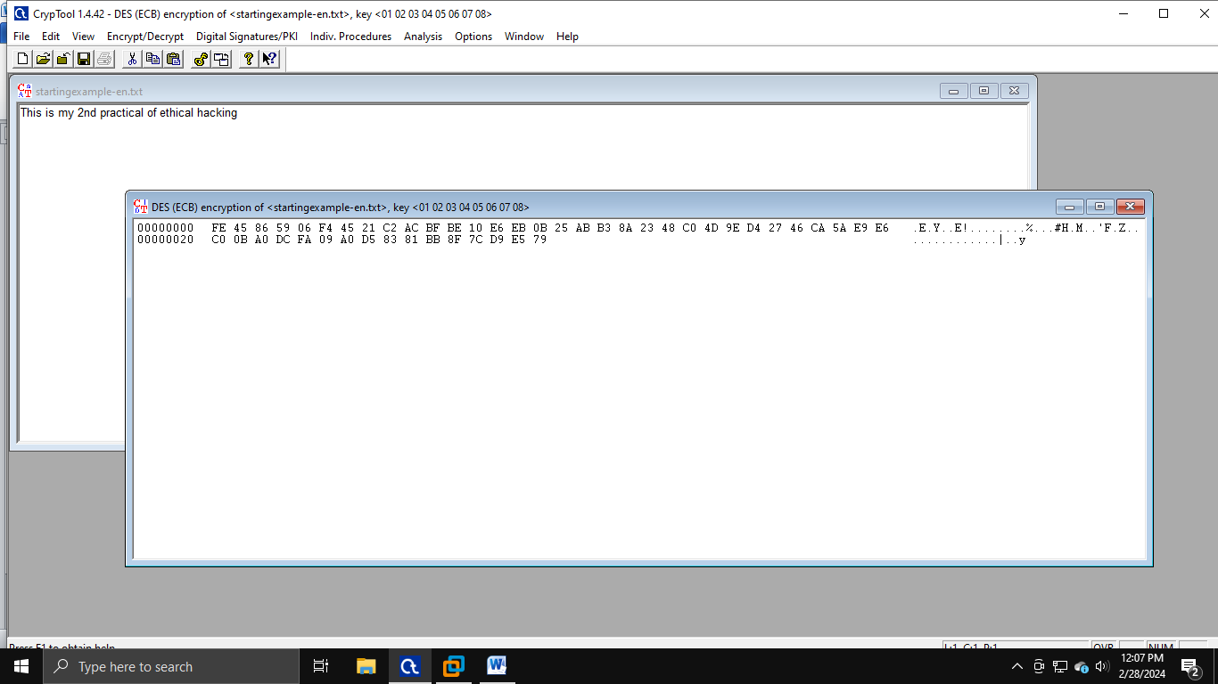

**Decrypt:**

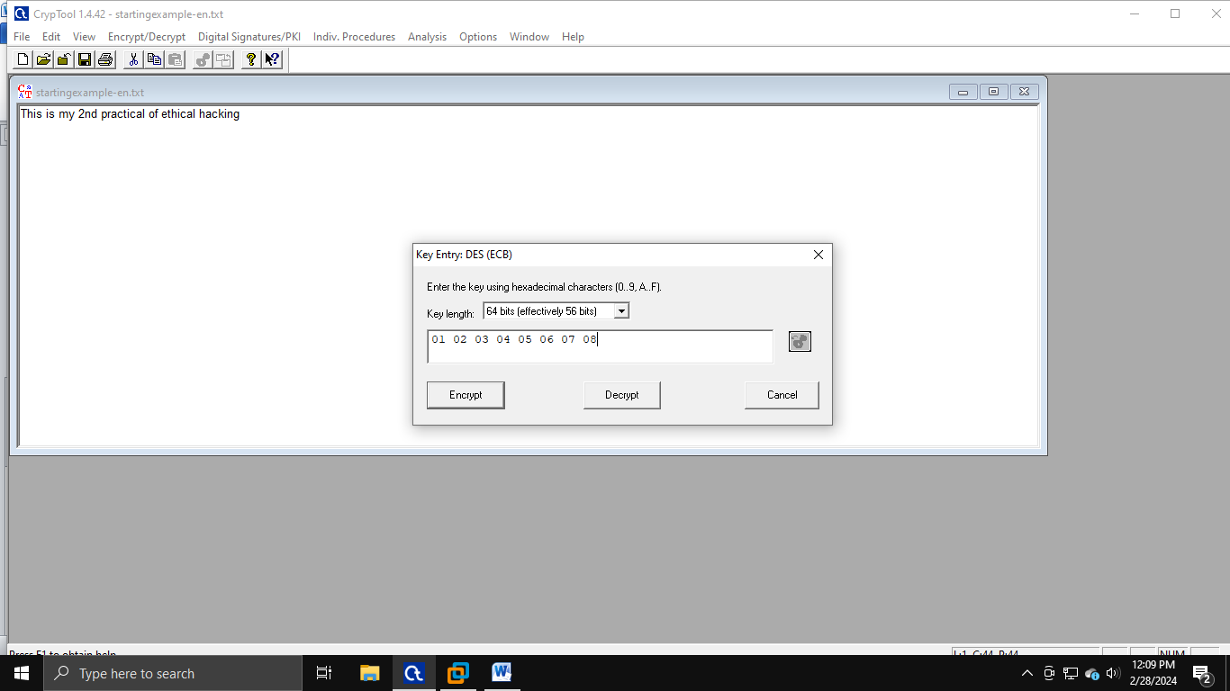

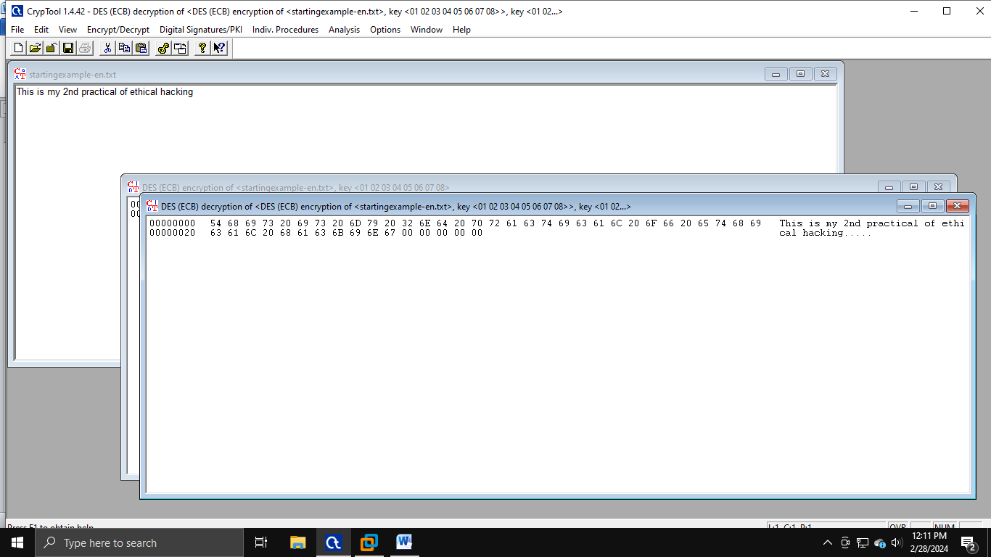

**Dictionary Attack :-**

**Step 1:- Download Cain and Abel from respected url http://surl.li/pmhef**

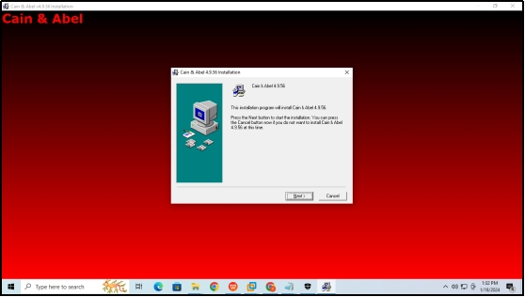

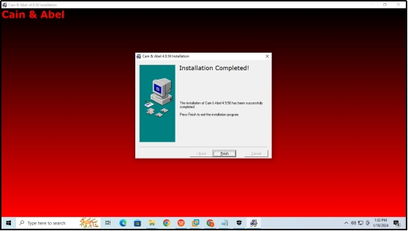

**Cain And Abel Interface :-**

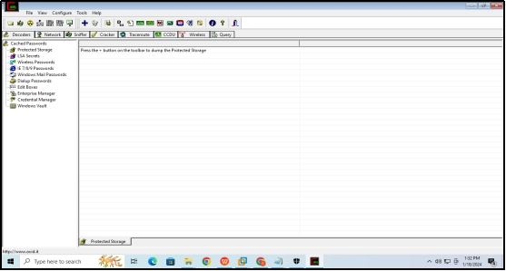

**Step 2 :- Click on Hash Calculator**

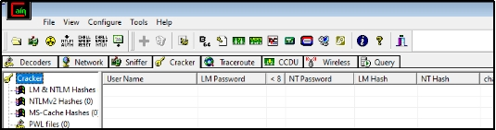

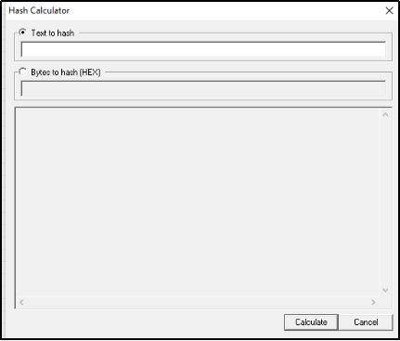

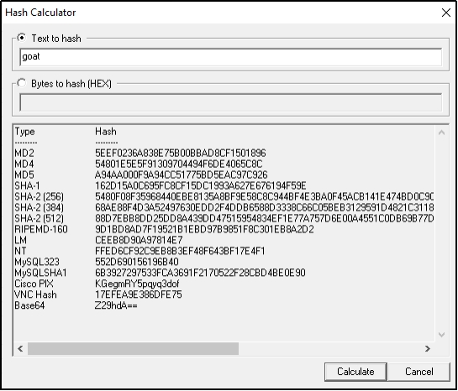

**Step 3 :- Select the MD5 Hash value**

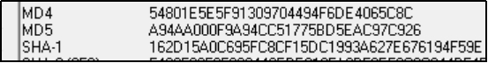

**Step 4 :- Select MD5 Hashes**

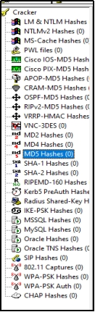

**Step 5 :-Right Click on screen and Select “Add to List”**

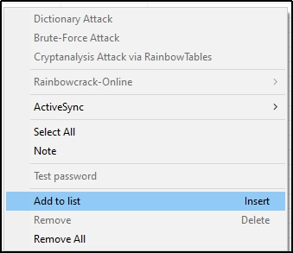

**Step 6 :- Enter the Hash Value**

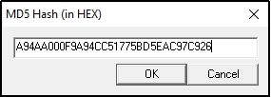

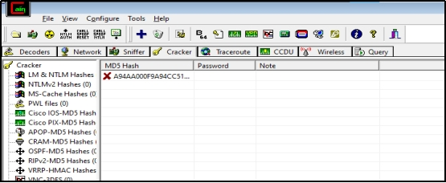

**Step 7 :- Right Click On Displayed code And Select “ Dictionary Attack ”**

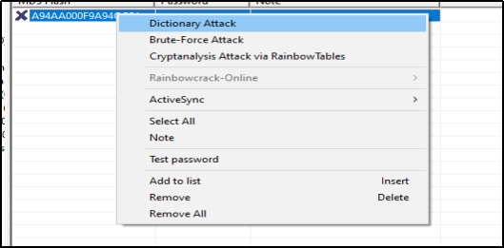

**Step 8 :- Right click and select Add to list**

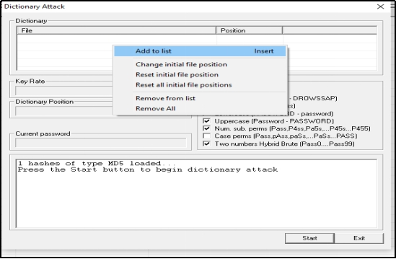

**Step 9 :- Select the Text file which contains number of passwords**

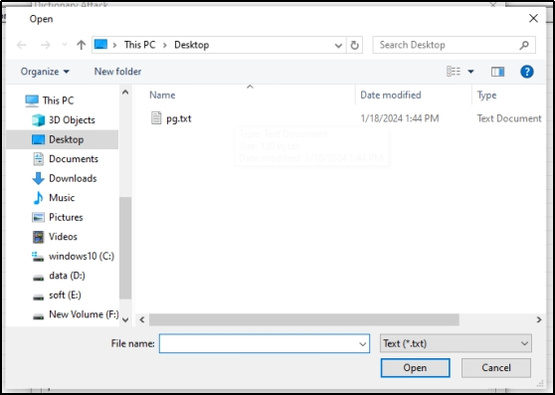

**Step 10 :- Right click on the Path and select “ Reset initial file position ” and then Start**

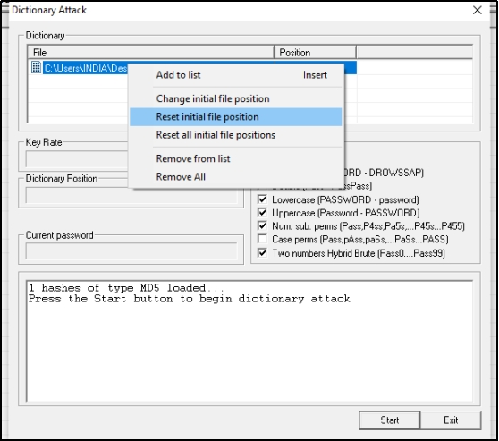

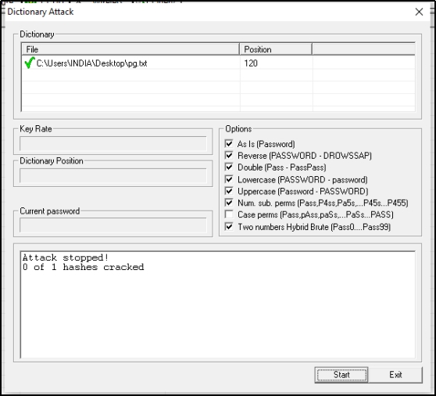

**Brute Force Attack :-**

**Step 1 :- Enter the password to generate Hash value**

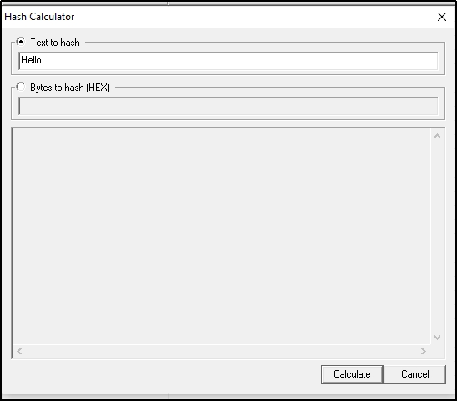

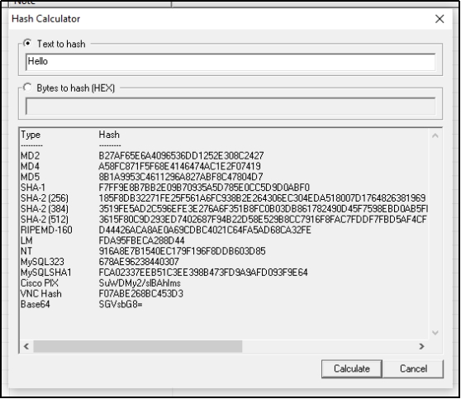

**Step 2 :- Copy the Hash value and paste in MD5 Hash**

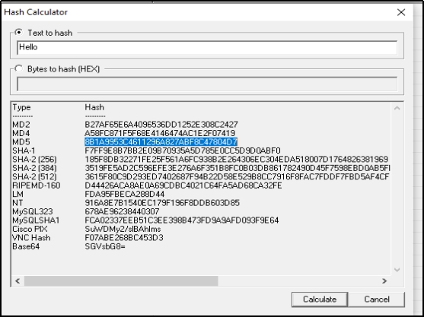

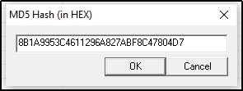

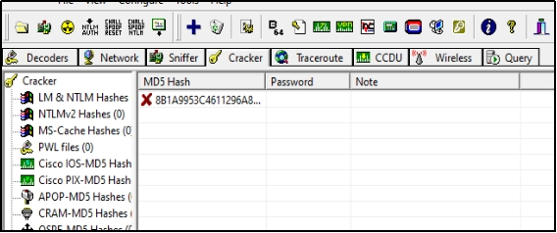

**Step 3 :- Right Click and select on “ Brute-Force Attack ”**

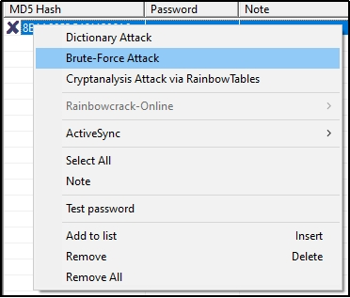

**Step 4 :- Select the Password Length and Click on Start**

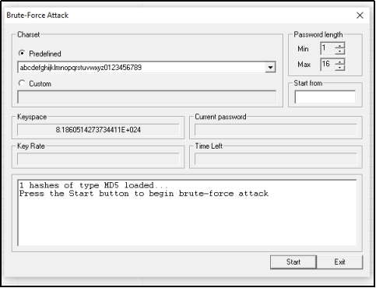

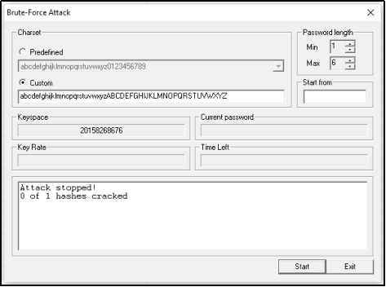

**Step 5 :- Password is Successful cracked**

